Moab Trip Report 2005
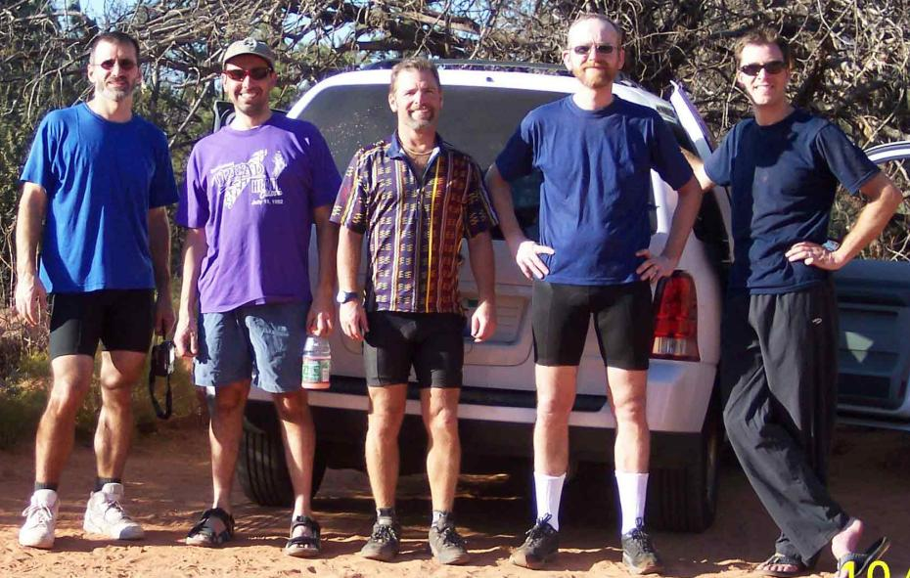
Edgar Civitello, Dan Dwyer, Bruce Overton, Nate Rockwell and Talima Pearson contributed to documenting the 2005 trip. Follow the link below for the 2005 write-ups and photos.
For more photos click here - the MTB main page at Overrock.net

